

**Cross Platform Applications (S3-21_SECTSZG585)**

**Assignment 2**

**Professor: Bhaskar Zeminder**

**Group 12**

**Group Members:**

**Meena Soujanya – 2021ct93015**

**Balakrishnan V – 2021ct93030**

**L Santhi Deepak – 2021ct93001**

**Aman Garg – 2021ct93028**

**Introduction:**

We have created GraphQL API to allow users to see the programs, track progress and set weekly goals. We have below four datasets.

**Users: {id, name, email ,weeklyGoal, totalCal }**

Users have four parameters which id, name and email essentials here we have added weeklyGoal where user can update the weekly goal in calories and compare with total calories spent.

**Workouts: {id, name, calBurn, sets, reps}**

These are basic workouts how many sets and reps users should perform to burn calories. This will be used in programs data set.

**Programs: {id,name,workouts,cal}**

Program will be what offered to users where they can select and complete a program for a day, it is combinations of multiple workouts from workouts dataset for example:

Program: {id:1, name:"Full Body",workouts:[1,2,3,6,7],cal:150}

Here workouts is basically an array where it has all workouts ids and total cal burned and name of the program.

**Tracker : {id,userid,programId,date}**

Tracker has references to user table and program table using userid and programid fields and date field represents when the user has done workouts.

**Query:**

Below are six queries which can be used to basically to query the database and get the information through graphql server.

1. **track** : this is used to track a single record from tracker this will show all the dependent records like user and program which also nested query of workout basically it will show all the information of a single tracker record.

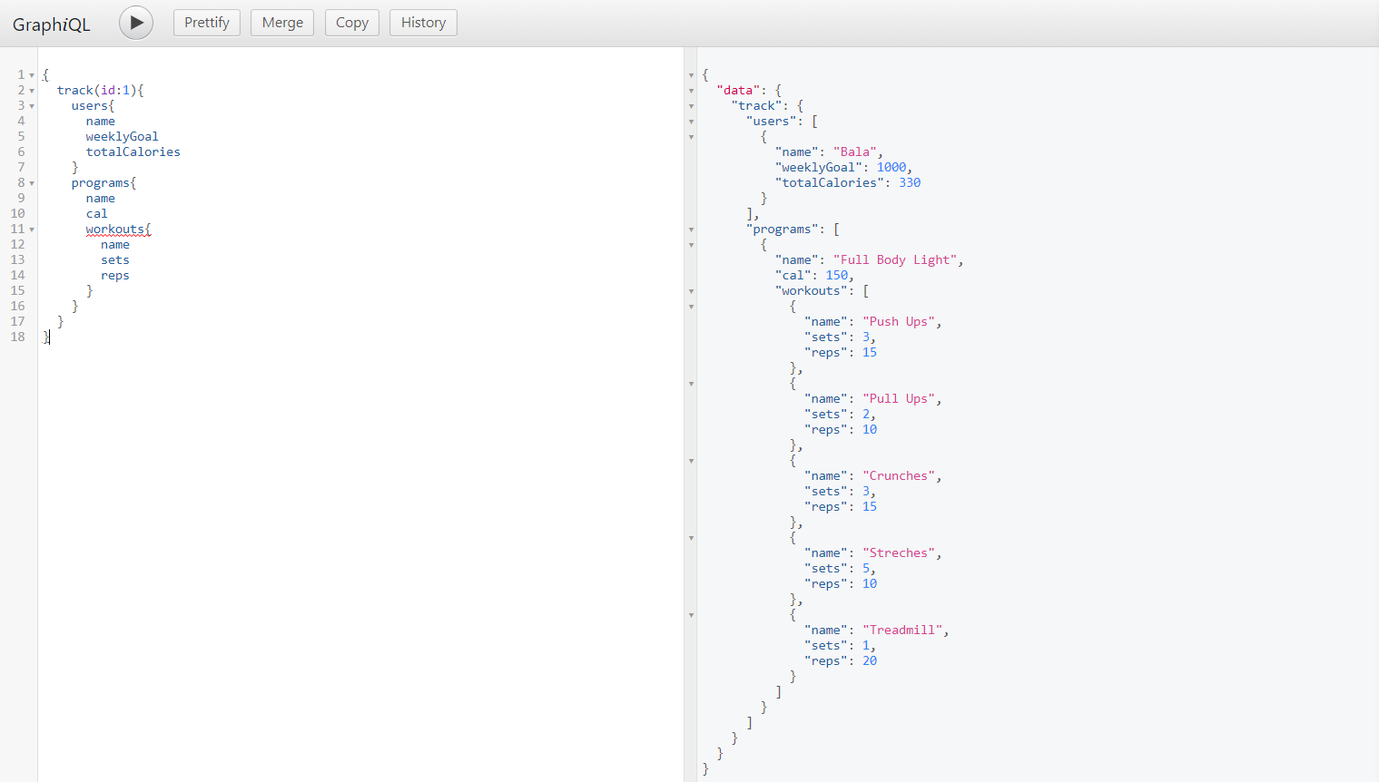

1. **Tracker**: this will contain all details that have been tracked till date with all dependencies same as above.

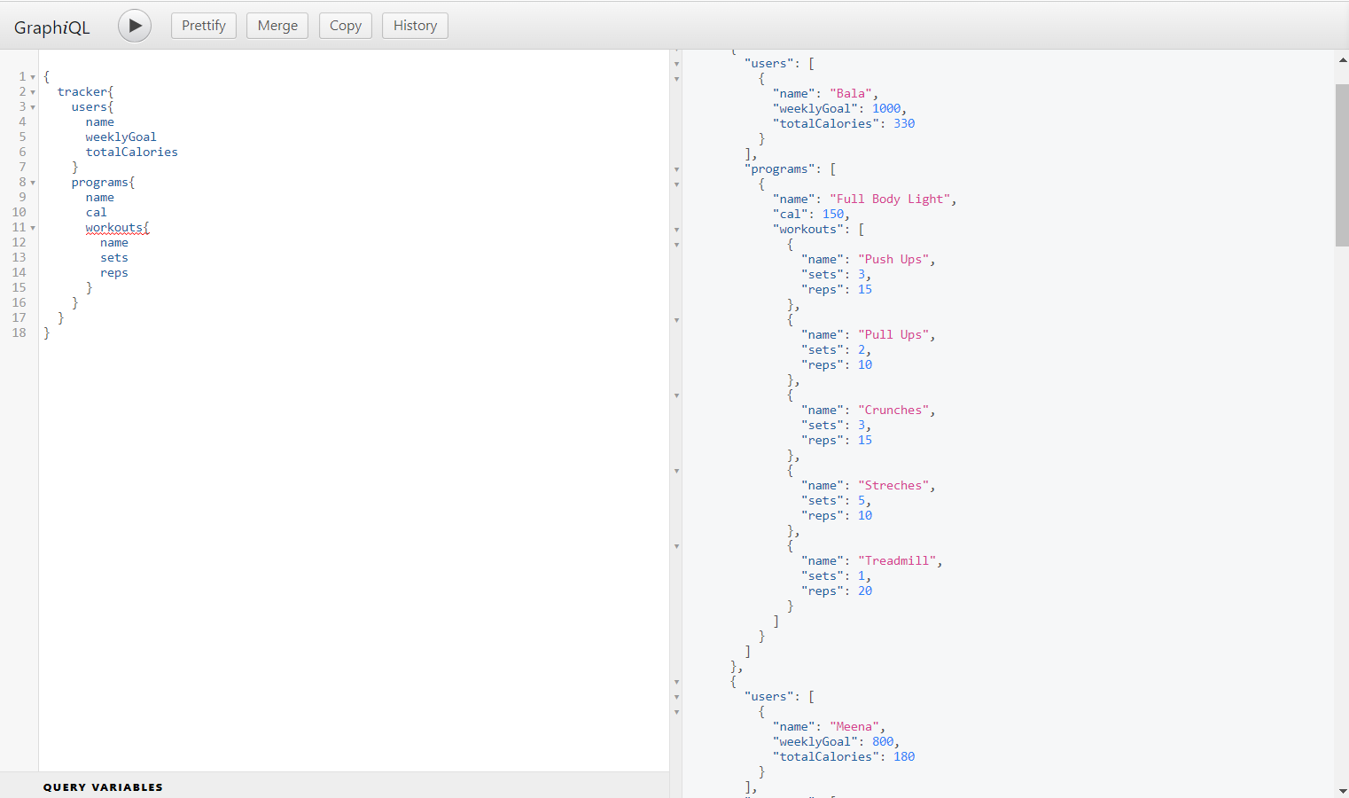

1. **Users**: This will contain all details of user along with tracker data which also can be used to compare goals, this will also contain all the programs completed by user which will calculate total calories of the user.

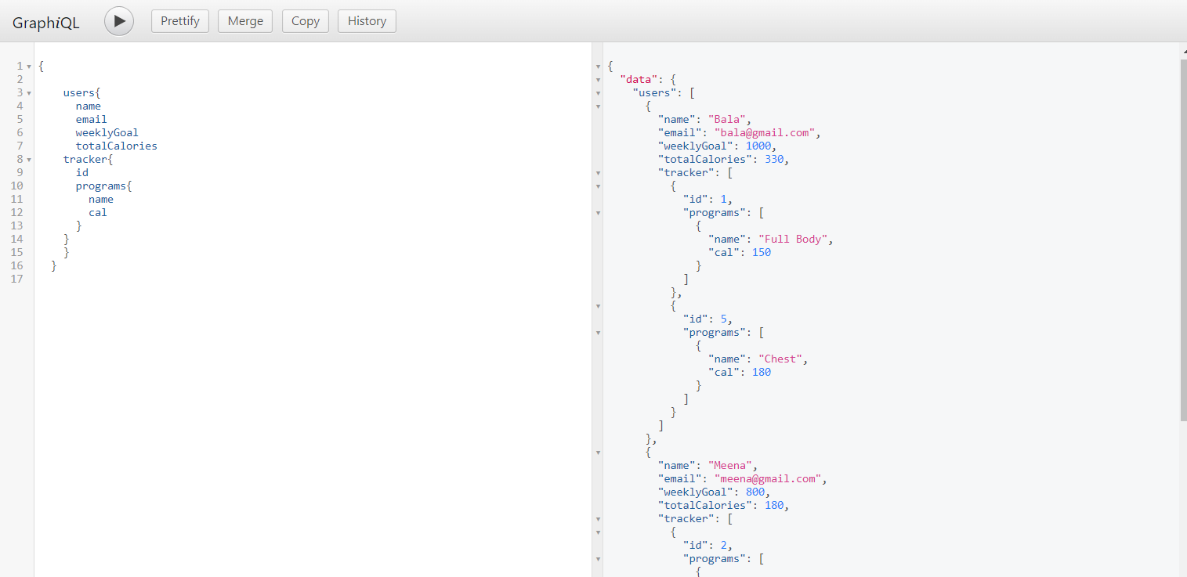

1. **User**: This returns a single record of a user with details. This will also contain all the programs completed by user which will calculate total calories of the user.

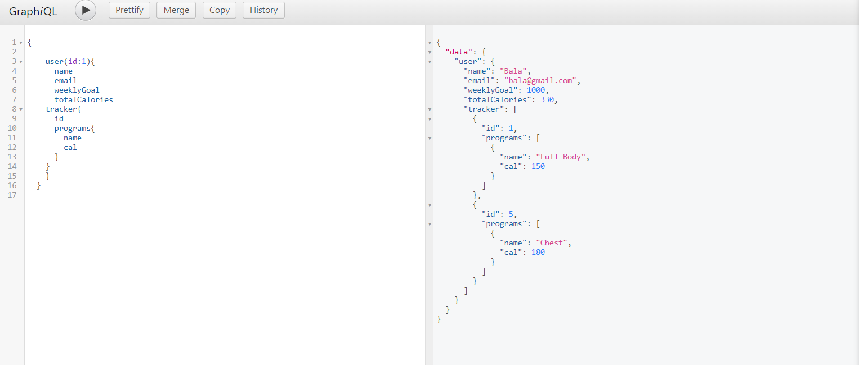

1. **Programs**: Returns list of programs which has nested object of workout which shows all workouts related to program and also calories spent.

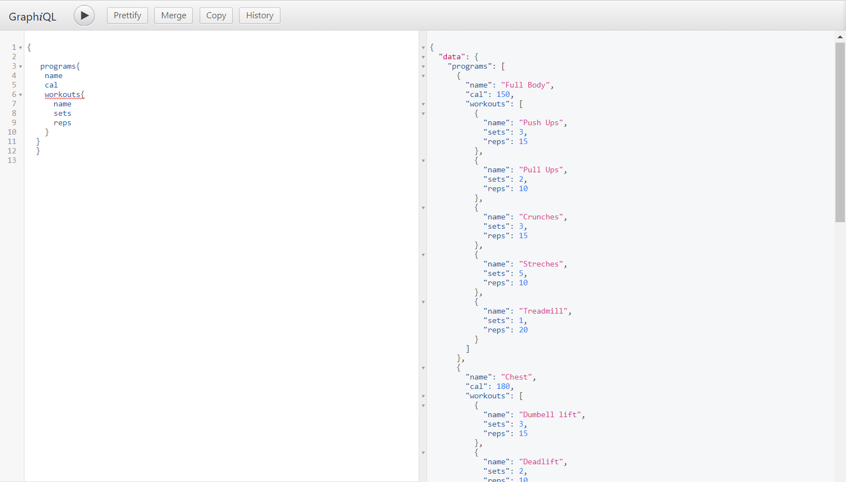

1. **Program**: based on id it will return program name, calories and workouts in the program.

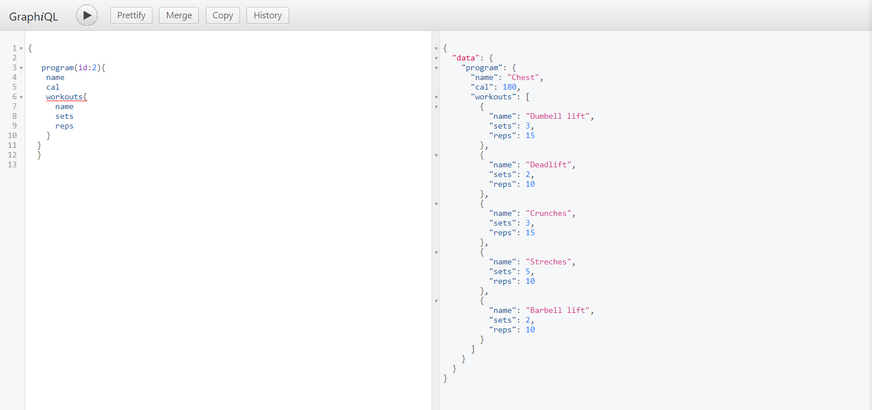

**Mutations:**

We have below mutations to add/update records to the dataset.

1. **addUser**: This is used to add user to the current users dataset, it will take all parameters required name, email and weeklyGoal then add it to the users table. id will be calculated as per users table length +1.

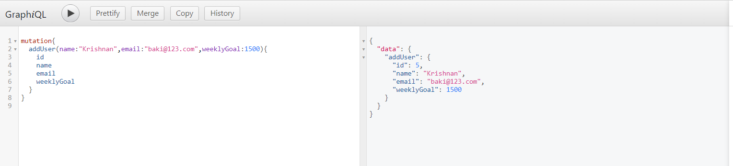

1. **trackProgress** : We can add a record to tracker data with date, userid and programid which indicates when the user does exercises and can be used to track progress.This will return user and program datasets based on userid and programid.

Totalcalories will be added to previous totalcalories based on program added to the user.

For example: below user had totalcal:150 before mutation once we have run below query it will add 180 as programid: 2 have cal: 180 which we be total of 330.

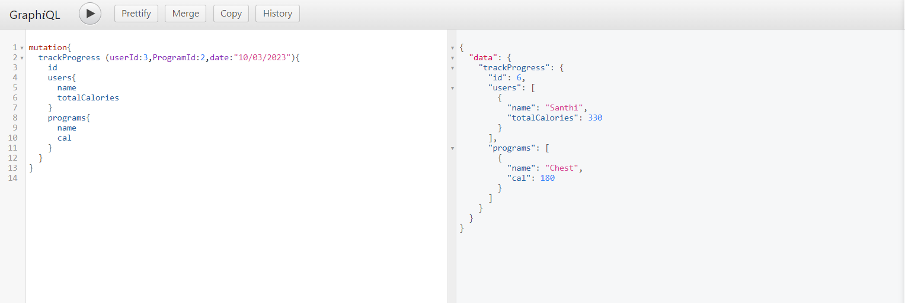

1. **updateGoal**: We can update the user’s weekly goal using id of the user, it will not create a new record but updates existing users record as per id.

